**GAS LEAKAGE ALERTING AND MONITORING SYSTEM – BATCH(B1-1M3E)**

**EMPATHY MAP**

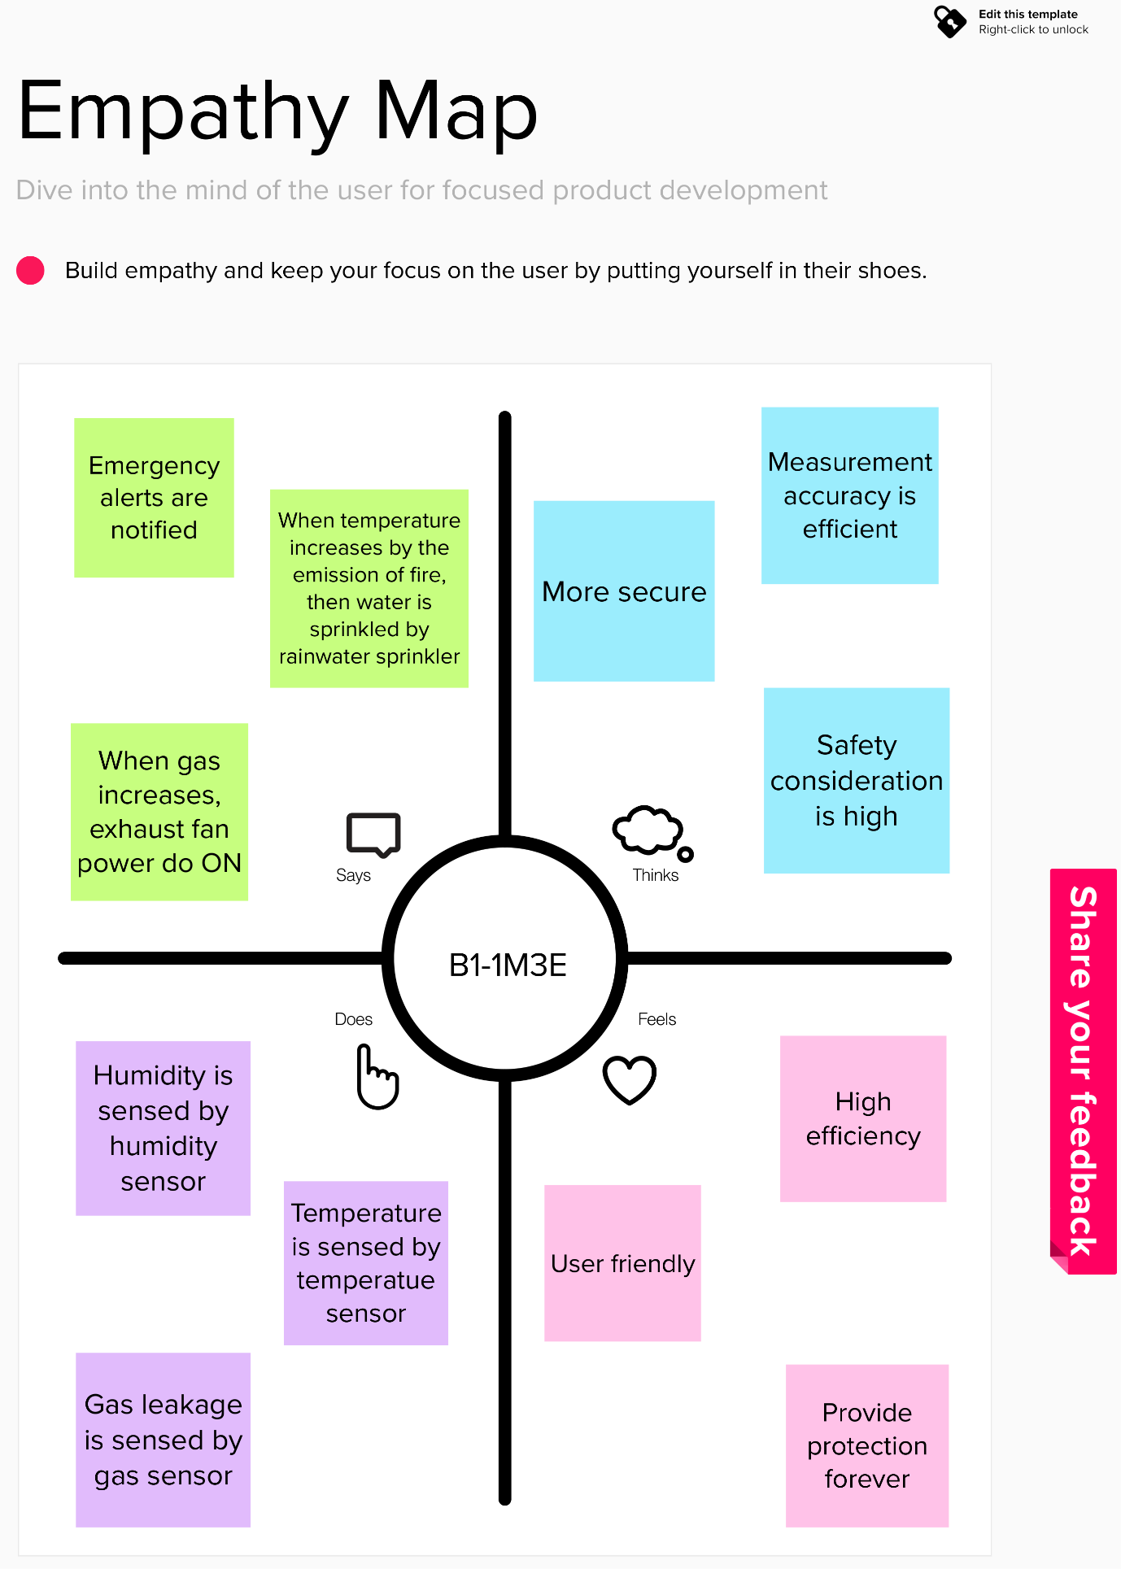

**PROBLEM STATEMENT**

Gas leakage is a serious issue which causes tremendous disasters at industries, houses and so on. These affect the people by even causing death. When gas leakage is not monitored properly then it causes some of the problems like fire accidents. Hence it is an essential role to monitor and alert the user when the gas starts leaking. When gas leakage occurs and considered into account, then there may be a chance of fire accidents. Owing to the characteristics of flammability, high energy and pressure, noxiousness, harm, continuous operation, excessive points and large length, complex environment, once the gas leaks, it is very likely to cause fire, explosion, poisoning and other serious accidents. An explosion can occur when a gas pipe is leaking in a confined space like home or business, the gas will mix with the air, increasing the pressure of the space. When there is a spark or fame (even a static electricity spark might be enough) present, the gas will ignite causing the explosion. When it is monitored properly by giving alert or notification to the users, then the leakage is controlled by them. Also, the gas leakage is controlled by exhaust fan. The fire is also controlled by sprinkling the rainwater (which is stored). This alerting system can be used in homes, industries and so on which helps in avoiding bulk losses due to fire accidents.